Lab No. 07

Abstraction

(Abstract Class with Pure Virtual Functions)

Lab Objectives | Following are the lab objectives:  - Understand the concept of abstraction in Object-Oriented Programming.  - Learn how to define abstract classes and pure virtual functions in C++.  - Implement abstraction to hide implementation details and expose only essential features.  - Apply abstraction to design flexible and extensible program structures.

Student ID | 10011 | Student Name |  | Sajjal Tariq
 | Marks |  | Obtained Marks |  | Comments
Task 1 | 20
Task 2 | 20
Task 3 | 20
Total Marks | 60
 | Lab Instructor

Pure Virtual Functions and Abstract Classes in C++

What is an Abstract Class in C++?
An abstract class is a class that cannot be used to create objects directly. It is meant to be a base class that provides a common interface but doesn't define full behavior.
A class becomes abstract if it has at least one pure virtual function.

A class that contains a pure virtual function is known as an abstract class.
We cannot create objects of an abstract class. However, we can derive classes from them, and use their data members and member functions (except pure virtual functions).

What is a Pure Virtual Function?
A pure virtual function is a function declared in a base class that must be overridden in any derived class.
It is written like this:
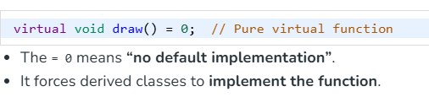
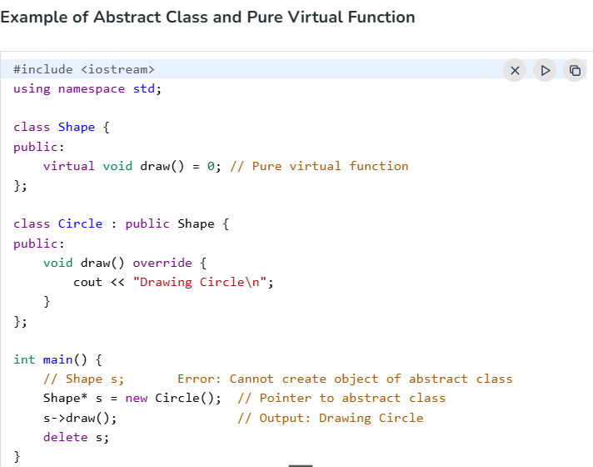

Let's take an example,
Suppose, we have derived Triangle, Square and Circle classes from the Shape class, and we want to calculate the area of all these shapes.
In this case, we can create a pure virtual function named calculateArea() in the Shape. Since it's a pure virtual function, all derived classes Triangle, Square and Circle must include the calculateArea() function with implementation.
A pure virtual function doesn't have the function body and it must end with = 0. For example:
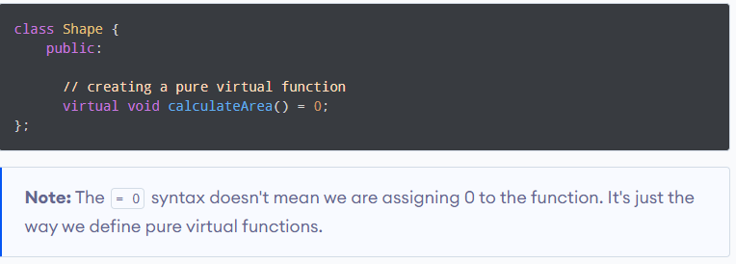
In the above example, the class Shape is an abstract class.
// C++ program to calculate the area of a square and a circle

#include <iostream>
using namespace std;

// Abstract class
class Shape {
protected:
float dimension;

public:
void getDimension() {
cin >> dimension;
}

// pure virtual Function
virtual float calculateArea() = 0;
};

// Derived class
class Square : public Shape {
public:
float calculateArea() {
return dimension * dimension;
}
};

// Derived class
class Circle : public Shape {
public:
float calculateArea() {
return 3.14 * dimension * dimension;
}
};

int main() {
Square square;
Circle circle;

cout << "Enter the length of the square: ";
square.getDimension();
cout << "Area of square: " << square.calculateArea() << endl;

cout << "\nEnter radius of the circle: ";
circle.getDimension();
cout << "Area of circle: " << circle.calculateArea() << endl;

return 0;
}
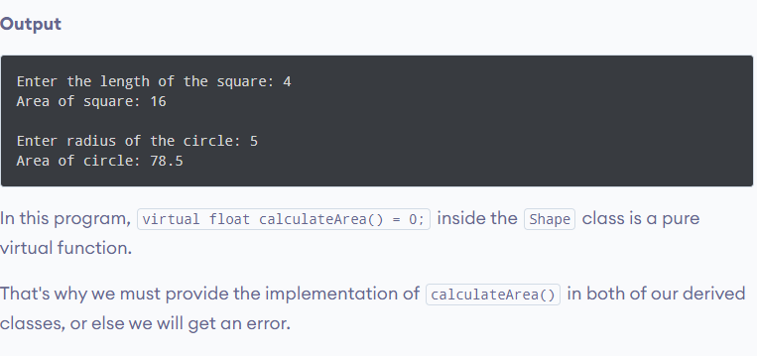
Lab Tasks
Task 1 (20 mark)
Scenario: A university wants to manage different types of staff members (e.g., Teacher, Clerk, and Librarian).
- Create an abstract class Staff with a pure virtual function calculateSalary().
- Derive classes Teacher, Clerk, and Librarian that implement the function differently (e.g., teacher based on lectures, clerk on hours worked, librarian on number of books managed).
- Demonstrate how abstraction allows defining a common interface but different implementations.
Code:
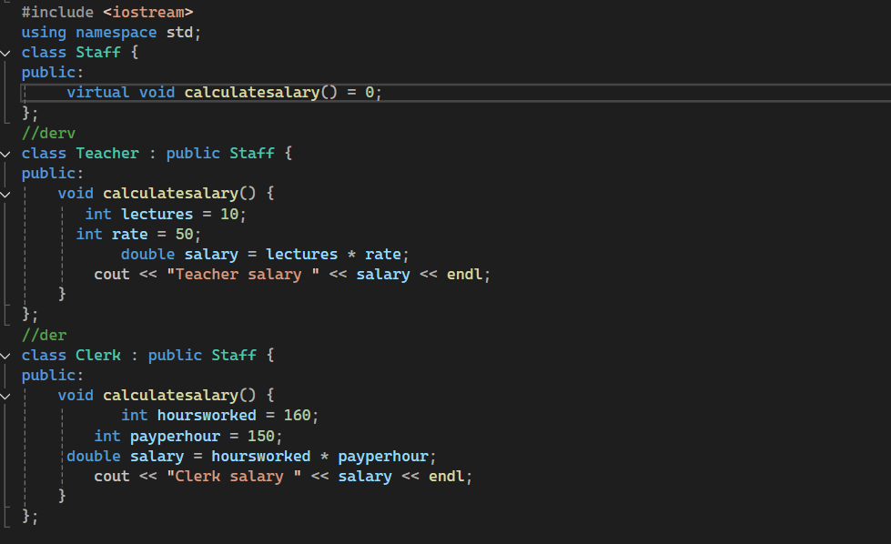
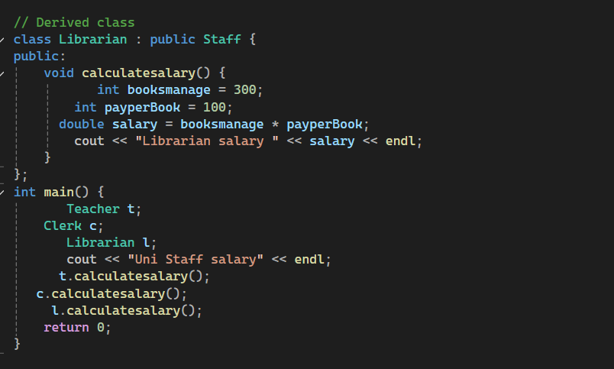
Output:
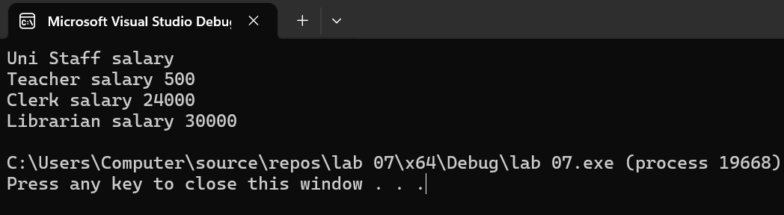

Task 2 (20 mark)
Scenario: A transport company has different vehicles (Car, Bike, and Bus).
- Create an abstract class Vehicle with a pure virtual function getFuelEfficiency().
- Each derived class should provide its own logic (e.g., Car = km/l, Bike = km/l, Bus = liters/100km).
- Write a program where the user enters details and the program outputs the fuel efficiency of each vehicle.
(Paste your code here)

Code:
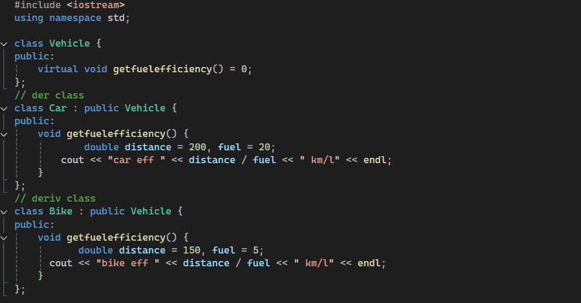
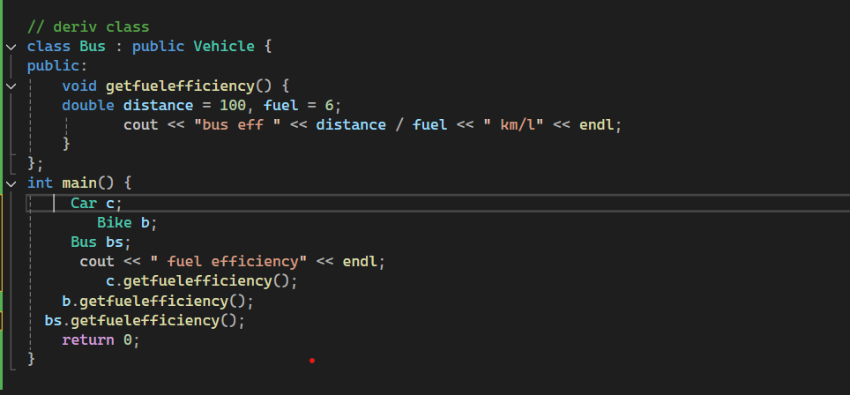
Output: 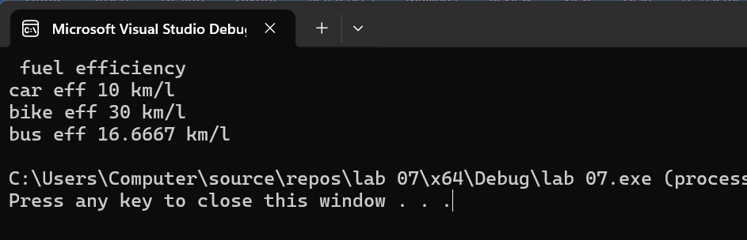
Task 3 (20 mark)
Scenario: An online shopping system has different types of payment methods (CreditCard, PayPal, CashOnDelivery).
- Create an abstract class Payment with a pure virtual function processPayment(float amount).
- Each derived class should override the function to display how the payment is processed.
- In main(), simulate a shopping cart checkout using different payment methods to show abstraction in action.
Code:
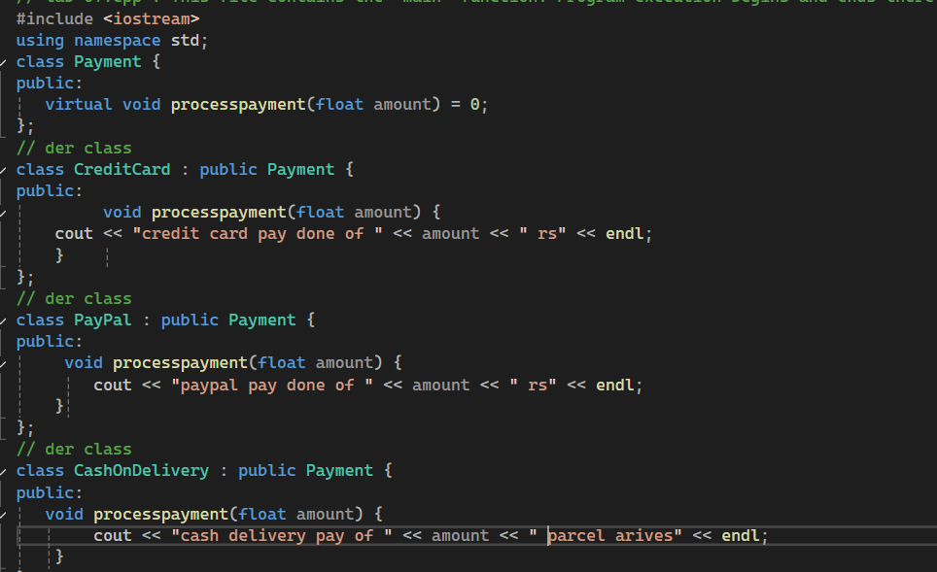
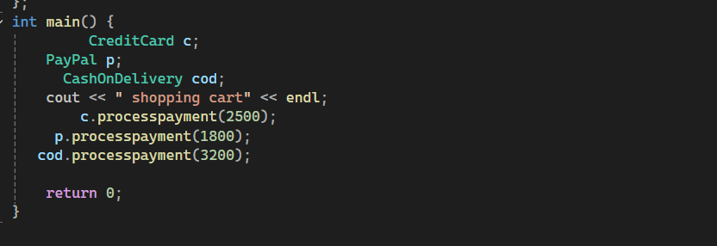

Output:
